# Grease Line kit:

# Well Site Guard units come with one integrated grease line installed just need to attach grease line to the stuffing box.

* For Stuffing box configurations with more than one lubrication point additional field installable Grease Line kits are available
* Mounts on the opposite side to the murphy gauge or ultrasonic switch

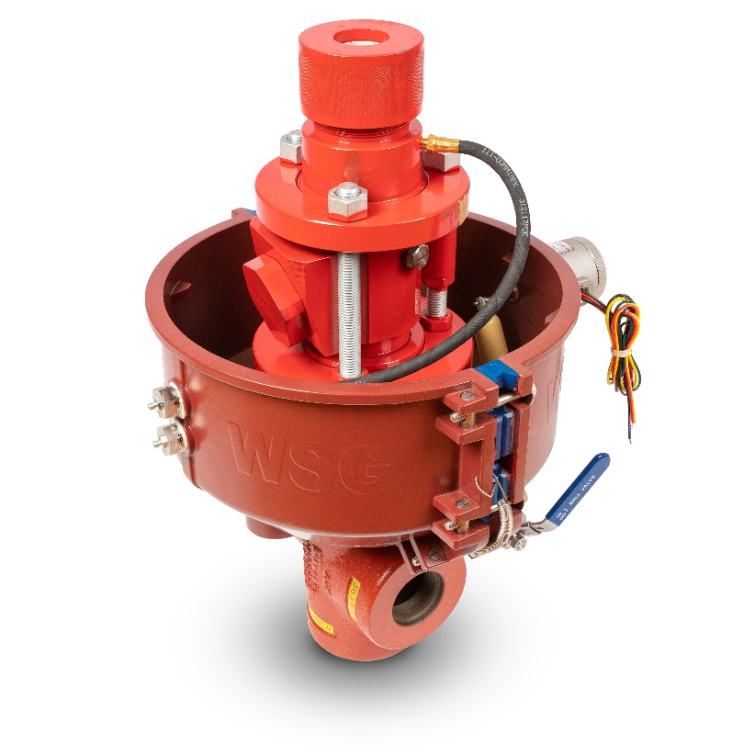

* **Important note: Inject grease through the hose assembly before attaching the hose to the stuffing box**

Picture is for new style Hercules Ball Stuffing box, with standard grease line kit and the addition of an optional second grease line kit